**Project Report**

**On**

**Solar PV in Aerial Imagery**

By: Team 5

# **Table of Contents**

1. Abstract
2. Introduction
3. Background
4. Data
   1. Data Description
   2. Challenges associated with the data
5. Methods
   1. Support Vector Classification using Histogram of Oriented Gradients (HOG) processed images
   2. Convolutional Neural Network (CNN)
6. Results
7. Conclusion
8. Roles
9. References
10. **Abstract**

This should be the one paragraph that captures the significance of what you did and why you did it.

Several models to classify whether images of houses contain a solar panel or do not contain a solar panel. Two models were determined as effectively classifying the images into the correct categories, as compared to a basic logistic regression model. The first was a Histogram of Oriented Gradients Support Vector Machine, with an accuracy on the test set of 83%. The second model was a Computational Neural Network, with an accuracy of correctly classifying the test images of 96%. Together, these models provide an effective tool to allow for the classification of residential homes as either having or not having solar panels. These tools can be used to further understand the distribution of solar panels in residential areas, allowing governments or other agencies to examine the effectiveness of their policy proposals as related to alternative energy and climate change.

1. **Introduction**

Global climate change is a serious problem with far reaching, long term consequences to all nations and economies. Most energy generation in the world comes from fossil fuels, the byproducts of which are implicated in causing the current phase of global warming. Much research has gone into looking for alternative sources of energy, including wind and solar power. However, these technologies still continue to be very expensive compared to more traditional means of energy generation, such as coal plants. To try and counteract this, many governments, including the government of the United States, have funneled money into both alternative energy research and alternative energy production. Despite numerous government funds, these technologies still only constitute a minority of energy generation in the US. The ultimate goal of this project will be to help the government inform best policies to encourage a broader use of renewable energy sources, particularly as applied to residential consumers. To that end, this project will focus on residential consumer’s use of solar panels on their houses. This is an attractive research group because it can measure both popular support for renewable energy sources (as opposed to industries complying with federal law) and the effect of government policies to encourage the use of renewable energy sources. There have been numerous programs in several US states to try and encourage the use of solar panels, including <https://www.energysage.com/solar/cost-benefit/solar-incentives-and-rebates/>

This project seeks to use satellite imagery to computationally determine if a house has a solar panel. This can help governments to determine if their policies of financially supporting solar panels are yielding more solar panels on private homes. This process can then be used in conjunction with other studies to determine if government policies concerning residential solar panels are effective at increasing the use of solar panels.

1. **Background**

Computer Vision has been a growing field in the past several decades. Recently, with the combination of feature extraction and machine learning methods, the accuracy of the models that allow computers to be able to “see” and identify specific objects from pictures has risen dramatically. This project seeks to use these methods to recognize solar panels from satellite images.

* 1. **Solar panel identification from satellite images**

Solar panel identification is beneficial for both government and private organizations since they can make energy policies or marketing plans by analyzing the solar development patterns. There are already some previous studies applied to machine learning methods to identify solar panels from satellite images. For example, “The DeepSolar Project” conducted by Stanford University, “constructed a comprehensive high-fidelity solar deployment database for the contiguous U.S.” 4 The purpose of the project is to create a database for people who are interested in how the solar panels are installed in the different area in the U.S. to conduct further analysis or research. The team applied the classification method based on Google Inception V3 to identify whether there is any solar panel in the piece of the image.4 If an image is classified as having a solar PV array, segmentation using the CAMs method would be conducted to estimate the size of the solar panels.5 Though the purpose of the project is slightly different from this current project, the basic steps are the same as this project- detect solar panels from aerial images. Image processing and image classification are other important parts of this project to identify solar panels from the images.

* 1. **Image Processing**

Image processing is a subfield of signal processing, which uses computers to process digital images. This has been studied for decades since the 1950s.6 SSince the digital images are represented using matrices, this allows scaling, color conversion, image enhancement, and other useful methods to be applied to the image by adjusting the value in the matrices. Moreover, image processing can be used to filter out the information from the high dimensional features of the images. In a study of detecting plant diseases, image processing was applied to the image, for example, transforming the color into greyscale in order to filter out extraneous information then conduct image classification.7 Similar image processing methods are conducted in this project to prepare training data for the chosen image classification models.

* 1. **Image Classification**

Image classification “refers to a process in computer vision that can classify an image according to its visual content”.8 However, because of the high dimensions of features of the images, it is computationally infeasible to use all these features to train models. Moreover, “look[ing] at high-resolution images it is very likely that a neighboring pixel belongs to the same land cover class as the pixel under consideration.”7 Therefore, “implementing feature extraction, and selecting suitable variables for input into a classification procedure are all important” 9 since we can make full use of the features and also reduce the dimension of the data. Some image processing methods such as Histogram of Oriented Gradients (HOG) 10or Scale-Invariant Feature Transform (SIFT)11 are famous as tools to extract informative features from the original image. With these filtered features, researchers can apply supervised machine learning methods to conduct image classification with high accuracy compared to using original images. One of the frequently used methods that can be applied to image classification are Support Vector Machines (SVM).12 In the study of image classification, it is stated that SVM “can generalize well on difficult image classification problems where the only features are high dimensional histograms,” by comparing the performance with KNN-based models, tuning the SVM model itself, remapping the input data.13 The analysis process of this project would be similar to the previous work since the goal of this project is to find a good combination of transformed original data and a well-tuned model to identify solar panels in the image with high accuracy.

1. **Data**

The data primarily comprised of satellite imagery of rooftops with or without a solar photovoltaic array(s). However, images without any rooftops/houses with solar array(s) installed were also part of the dataset.

Moreover, the solar array(s) had different type of structural configuration (or the arrangement) and orientation across the images in the data. The images in the dataset had a resolution of 101 x 101 pixels. And, the data was provided in two sets, training, and testing data.

* 1. **Data Description**

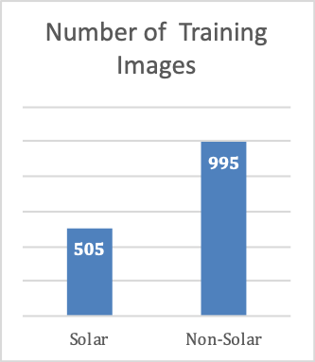

Figure 1: Number of Training Images for each label

The *Training* data comprised of 1500 labeled satellite images comprising of 505 images *with* solar photovoltaic array(s) on the rooftop, and 995 images *without* any solar photovoltaic array(s). *Figure 1* shows the distribution of images for each class i.e. solar and non-solar

The *Testing* data comprised of 558 unlabeled satellite image data *with* and *without* solar photovoltaic array(s).

*Figure 2* shows sample images *with* solar PV array(s) installed in different locations, configurations, and orientations having different intensity in color associated with the panels in the array. *Figure 3* shows sample images *without* solar PV array(s).



Figure 2: Examples of images with Solar PV array(s)



Figure 3: Examples of images without Solar PV array(s)

* 1. **Challenges associated with the data**

The primary challenge associated with image classification for this dataset was identifying certain edges and colors which were specific to solar array(s). Since the array(s) were mounted on the rooftop, which had similar edges to the array(s), distinguishing roof and arrays was the main challenge. Another interesting challenge with detecting the images was identifying array(s) which had different colour intensity and arrangement, distinguishing them from the images of similar structures such as top of car in similar colour, or roads and pathways. Another critical problem with image data is high dimensionality. Colored images with 101 x 101 pixels correspond to 30,603 features, which is considered as very high dimensional data, and will be computationally expensive when directly used in a machine learning algorithm. Dimensionality reduction is an important step when working with image data for faster computation.

One of the many traditional ways of solving the problem of feature extractions from these kinds of images is manipulation of the colour scheme to increase contrast between the object and noise. Contrast helps in distinguishing features (in other words the RGB or Grayscale value) of the object from the noise around it. Subsequently, dimensionality reduction methods such as Principal Component Analysis (PCA) could be used to reduce the dimensionality of the image features. Interestingly, resizing of images is a much faster way to reduce dimensionality, but it could lead to loss of important information from the image. Another method which is being widely used for dimensionality reduction and feature extraction with edge detection is Histogram of Oriented Gradients (HOG)[101] which is discussed more in the coming sections.

Convolution is another widely use process for feature extraction and dimensionality reduction, primarily with conjunction with neural networks for image classification. The process of convolution is also discussed in the coming sections.

1. **Methods**

Serving the primary objective to classify identifying images with solar photovoltaic array(s). different machine learning models were created including simple logistic regression, random forest classifier, support vector machines (SVM), and Convolutional neural networks (CNN). Prior to classification, several methods for feature extraction and dimensionality reductions such as PCA, HOG and Convolution was also used.

* 1. **Support Vector Classification using Histogram of Oriented Gradients (HOG) processed images**

Following the classical approach of image processing, images were pre-processed in terms of color, orientation and rescaling. Following which, feature extraction with edge detection and dimensionality reduction was performed using HOG. And finally, the extracted features were used to train a SVM model for identification of images with solar array(s). *Figure 4* shows the steps in image processing and classification.

Figure 4: Process of image pre-processing for SVM

* + 1. **Image Pre-Processing using Pillow**

Images were pre-processed using *Pillow* library in python (*Figure 5*). All the colored training images were converted to grayscale to reduce the dimensionality from 3 channel to 1 channel. Subsequently, images were equalized to increase the contrast between solar arrays and surroundings, following which the images were randomly rotated to capture different orientations of solar arrays. Finally, the images were rescaled from 101 x 101 pixels to 64 x 64 pixels for the purpose of dimensionality reduction.

Figure 5: Image pre-processing steps

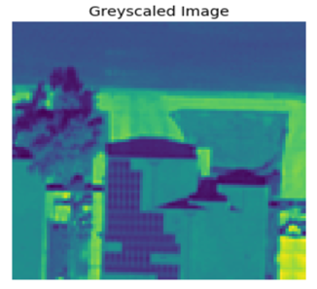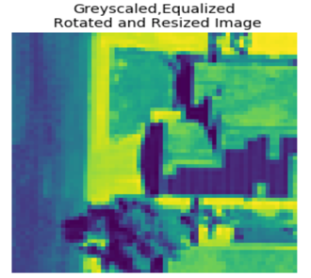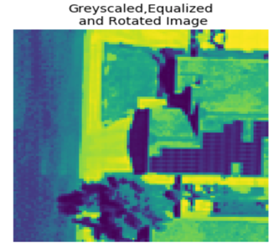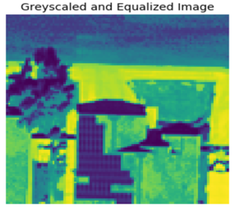

Gryscale



**Greyscale**

**Equalize**

**Rotation**

**Resizing**

* + 1. **Histogram of Oriented Gradients (HOG) for edge detection**

Histogram of oriented gradients (HOG) is a feature descriptor used to detect objects in computer vision and image processing. A feature descriptor is a representation of an image or an image patch that simplifies the image by extracting useful information and throwing away extraneous information. The HOG descriptor technique counts occurrences of gradient orientation in localized portions of an image - detection window, or region of interest (ROI). Localized portion of an image can be described as a block of consecutive pixels of the image, where the block moves over the entire grid space of an image.

In simple terms, HOG generates a histogram of orientations (which correlates to the change of intensity of corresponding pixel values in a block) for a block. A block is made of cells and each cell overlays certain number of pixels of an image. The orientations capture the direction of edges in an image, thus generating a feature space portraying the outline of an object in the image. The block moves across the image and generates histograms for a group of cells, thus reducing the dimension. *Figure 6* shows the images distributed in blocks, and gradient value and direction associated with each block.

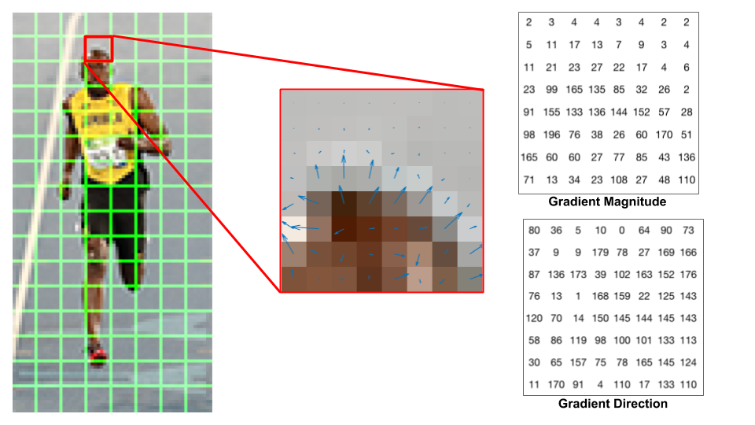

Figure 6: Blocks of images represented in terms of gradient direction and magnitude. (Source: www.learnopencv.com/histogram-of-oriented-gradients)

The 64 x 64 pixels images were processed using HOG, evaluating 16 x 16 pixels per cell with 4 cells (2x2) per block. The gradients based on their direction were binned into 8 bins for each cell and frequency of the histogram from the 4 cells (2x2) in a block were normalized using L2 norm, generating 8 features per block. Normalization is key step which accounts for lighting variations across the image. *Figure 7* shows the HOG features with oriented vector (which could be matched with corresponding edges of the original image) for few training images.

* + 1. **Classification using Support Vector Machine (SVM)**

For classification of images turned feature vectors, Support vector machine or SVM classifier was used. SVM is a non-probabilistic linear classifier, and works very well with high dimensional data, which in this case was the best choice, with feature space of 288 dimensions.

An SVM classifier with the default ‘rbf’ kernel, from the SVM library by Scikit learn was used for classification. Moreover, in order to check the generalization performance of the model, a 10-Fold Cross Validation was performed using the entire training data of 1500 pre-processed images. Subsequently, model performance was evaluated in the using the test data of 588 processed images.

Model performance was evaluated using Receiver Operating Characteristic (ROC) curve with Area Under the curve (AUC), Precision-Recall curve (PR) with Average Precision value. However, since the data was un-balanced, F-1 score was computed to evaluation of model performance. Model performance is further discussed in the Section 6.

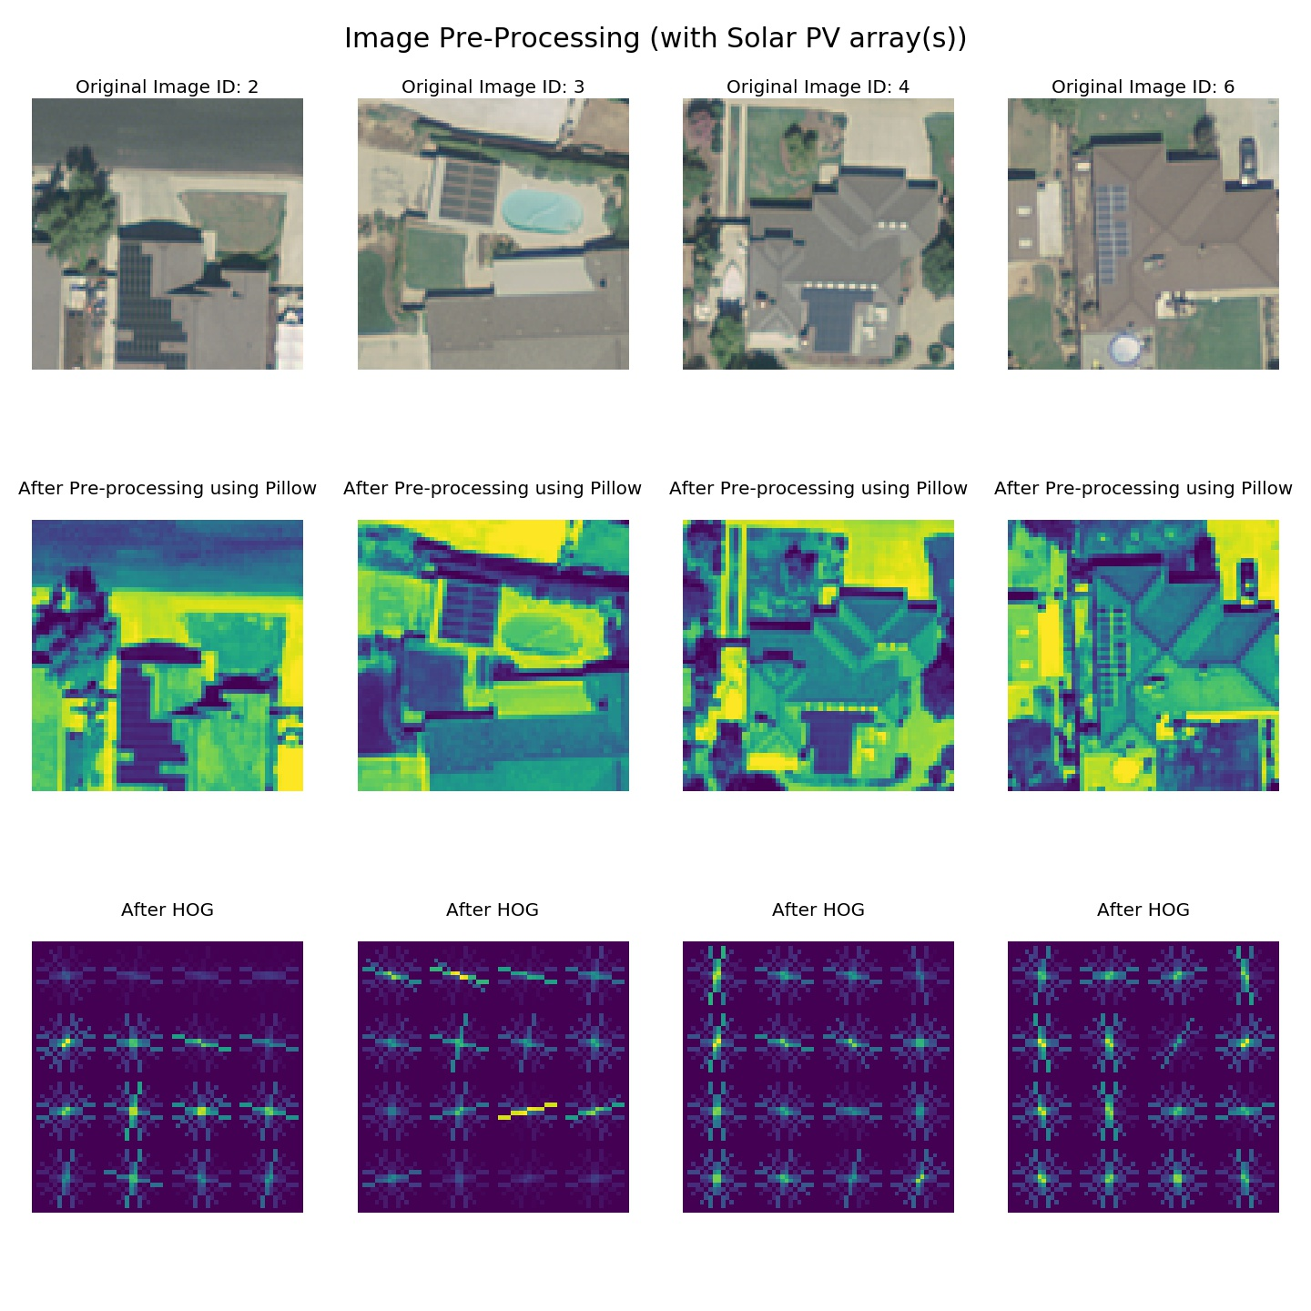

Figure 7: Image classification steps for SVM

* 1. **Convolutional Neural Network (CNN)**

1. **Results**

Overall, both the models SVM, and CNN performed very well in identifying images with solar array(s). However, as expected the Convolutional Neural Network outperformed every other model used for classification. Following is the evaluation of model performance of both the models.

* 1. **Model performance for SVM**

|  |  |  |
| --- | --- | --- |
| Confusion Matrix for SVM | | |
|  | **Predicted Solar** | **Predicted Non-Solar** |
| Solar | 291 | 214 |
| Non-Solar | 97 | 898 |

After image pre-processing followed by HOG, SVM classifier performed with an **AUC of 0.84** over the training data when cross validated to check model generalization performance, and **0.86** over the test data. As can be seen from the confusion matrix, model performed relatively better in identifying images without solar array(s). However, the model was able to correctly identify 60% of the images with solar PV array(s).

Further analysis of the classified images revealed several interesting insights. Based on the visual inspection of the True positives, False positive and False negative images (*Figure 8*), following conclusion can be made about the model.

* The model was able to capture the array(s) which had a good contrast with the background/surface on which they were installed and also had a linear structure.
* However, model was mis classifying the images as positive class (with solar) which contained shadows (which have a same appearance as that of solar array(s) and also had repeated rectangular edges.
* The model failed to identify images having low contrast between the solar array(s) and the background or had a whiter boundary in the solar array(s), which was giving the same appearance as that of a rooftop.

Model performance was visualized using ROC curve and Precision-Recall curve (see model comparison). Also, since the data was unbalanced, F-1 score was also evaluated to check the model performance. The model had an F-1 score of 0.78.

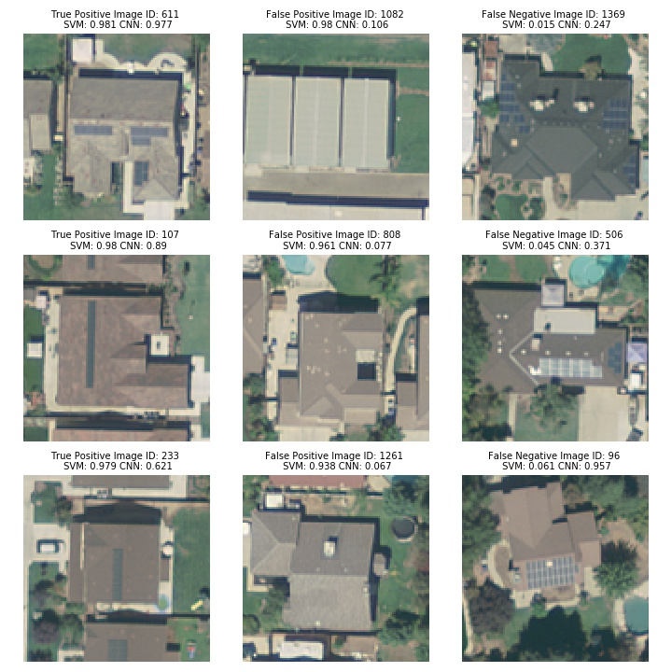

Figure 8: Classification performance of SVM showing images classified as True Positive, False Positive, and False Negatives (at threshold 0.5)

* 1. **Model Performance for CNN**

|  |  |  |
| --- | --- | --- |
| Confusion Matrix for CNN | | |
|  | **Predicted Solar** | **Predicted Non-Solar** |
| Solar | 398 | 107 |
| Non-Solar | 5 | 990 |

Convolutional neural networks performed extremely well as compared to the SVM model. The CNN had an AUC of **0.99** for the training data**, 0.97 for the test data**. As can be seen from the confusion matrix, the model had a high precision, with only 5 false positive. Also, as compare to SVM, CNN was correctly able to identify almost 75% of the images with solar array(s).

Further analysis of the classified images revealed several interesting insights. Based on the visual inspection of the True positives, False positive and False negative images (*Figure 9*), following conclusion can be made about the model.

* The model was able to capture to different arrangement of solar array(s) with different orientations and shadows.
* However, the model did falsely classified images with blue colored objects arranged closely, blue surfaces or images with regular rectangular arrangements, as positive class.
* Also, it appears the model was not able to identify images with noise such as vegetation, and images having low contrast between the array(s) and background.

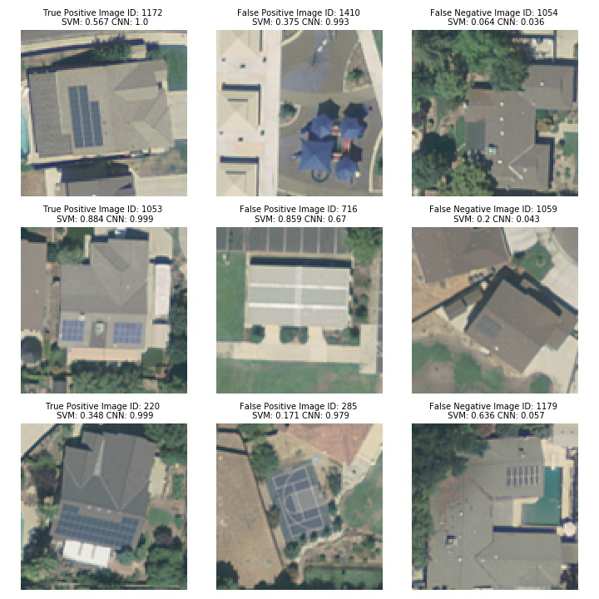

Figure 9: Classification performance of CNN showing images classified as True Positive, False Positive, and False Negatives (at threshold 0.5)

ROC and Precision-recall curve was plotted for the CNN model. The model had an F-1 score of 0.92.

* 1. **Comparison of model performance**

As stated earlier, CNN had much better performance as compared to that SVM model. Table 1 compares and contrast the performance metrics for both the models. Interestingly, since the data was unbalanced, even though CNN had an AUC of 0.99 for training data, the true model performance metric can be measured as the F-1 score, which was 0.92.

Table 1: Performance metrics for SVM and CNN

|  |  |  |  |  |
| --- | --- | --- | --- | --- |
| Model | AUC  Training (with CV) | AUC Testing | Average Precision | F-1 Score (for threshold 0.5) |
| SVM (w/ HOG) | 0.84 | 0.86 | 0.74 | 0.78 |
| CNN | 0.99 | 0.97 | 0.98 | 0.92 |

Precision-recall curve (*Figure 10 (left)*) shows the PR curve for SVM and CNN model. As can be seen the CNN had a much higher average precision as compare to SVM. Also, the ROC curve (*Figure 10 (right)*) shows the ROC curve for the SVM and CNN models.

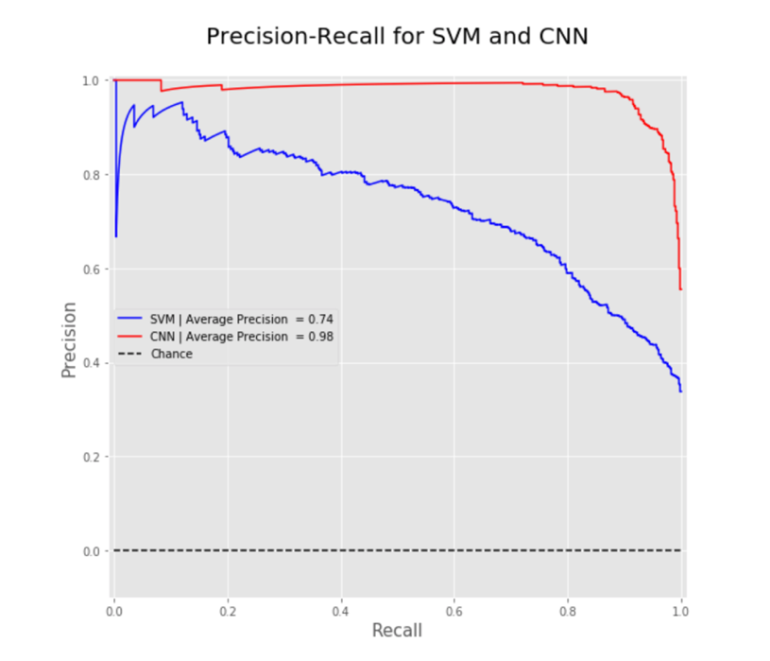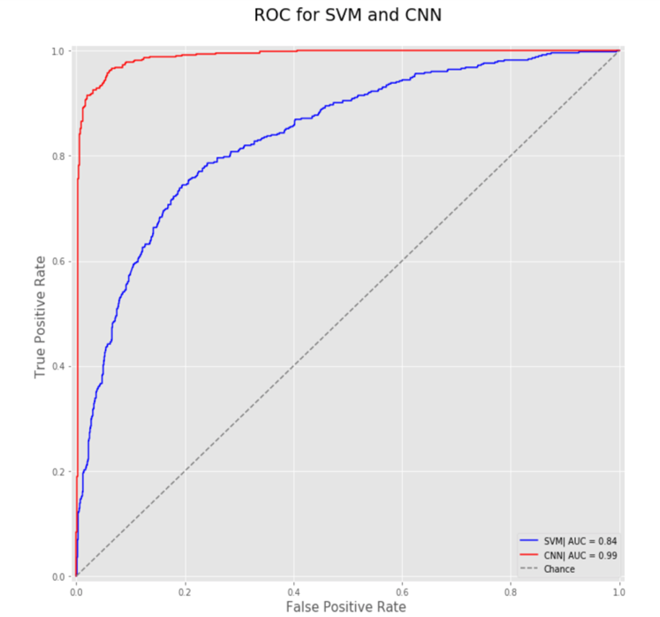

Figure 10: (Left) Precision-Recall Curve for SVM and CNN, (Right) ROC curve for SVM and CNN

The main advantage of CNN over the other models is because there is really minimum level of feature extractions human needed to supervise to the model. It detects the important features itself. In the solar PV case, the features from the original pictures are 101 by 101 by 3, and the sample size available is only 1500. For the models that require human supervised feature extractions, successfully extracting the important features can be a challenging task. In addition, the image features are much larger than the sample data that is available to train. For models doing much less feature extractions, the amount of training data presented is far under the needs. With only a fraction of the training samples than the features, it becomes a hard task for the model to find the important features. Thus, CNN is outperforming the other models.

However, there were cases when both the models failed to identify few images with solar array(s). Looking at the false negative images (*Figure 11*), it appears that both the models were not able to capture the features when the contrast between solar array(s) and the background was very low.

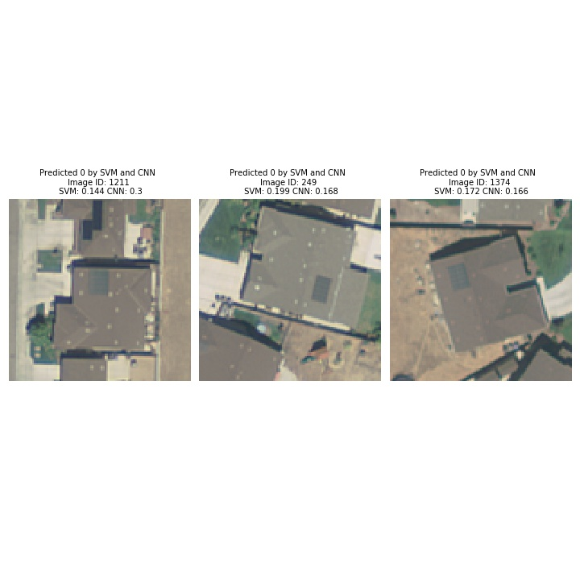

Figure 11: False negative images for both SVM and CNN

1. **Conclusions**

Out of the models created, the two best models, which achieved a significantly higher accuracy than a basic logistic regression, were the HOG SVM and the CNN models. The HOG SVM performed acceptably, achieving an accuracy of 83% on the test dataset. This model is much faster than the CNN, and could have applications where speed is necessary, but accuracy is not as much of a concern. In terms of strict accuracy, the CNN performed much better, with an accuracy of 96% at classifying images as correctly having or not having a solar panel on the house. The CNN clearly has an accuracy advantage over all other models at correctly classifying the images, however, it was much slower than any other model. This model would be preferred when accuracy is required, but speed is not a concern. As described in the introduction above, the solar panel image classification goal of this project could help inform policymakers or other stakeholders as they seek to experiment with and determine the best method to increase solar panel use. With an accuracy of 96%, the CNN model could be used to effectively determine the efficacy of policies targeted at increasing solar panel usage. This can be done by feeding satellite images into the model, allowing any level of government to analyze their policies effectiveness. Using this information, the government can then tailor the policies to further experiment with policies and legislation, with the ultimate goal of increasing solar panel usage, reducing reliance on fossil fuels, and combating climate change. Further research could include ways to boost the accuracy of this model even further, and to apply these image classification techniques to further questions of interest.

1. **Roles**

Following is the descriptions of individual contribution in the project by the members to the team.

1. **Akshay** worked on image processing and used Histogram of Oriented Gradients, to develop the SVM model.
2. **Melody Li** created a Computational Neural Network model for the images, which was then submitted as part of the final part of the competition.
3. **Tzu Chun** made several models, including
4. **Derek Wales** made several models, including (add more).
5. **Andrew Patterson** created and tested several models while using the grayscale component reduction, including a test of a basic logistic regression and an experimental QDA test, both of which were submitted as part of the competition. Andrew also wrote the introduction, background, conclusion, references, and other parts of the rest of the report.
6. **References**

1. Mora, C. et al. Broad threat to humanity from cumulative climate hazards intensified by greenhouse gas emissions. Nat. Clim. Change 8, 1062–1071 (2018).

2. DSIRE. https://programs.dsireusa.org/system/program?zipcode=27517.

3. What is U.S. electricity generation by energy source? - FAQ - U.S. Energy Information Administration (EIA). https://www.eia.gov/tools/faqs/faq.php?id=427&t=3.

4. Yu, J., Wang, Z., Majumdar, A. & Rajagopal, R. DeepSolar: A Machine Learning Framework to Efficiently Construct a Solar Deployment Database in the United States. Joule 2, 2605–2617 (2018).

5. Bolei Zhou, Aditya Khosla, Agata Lapedriza, Aude Oliva, Antonio Torralba 2016. Learning Deep Features for Discriminative Localization. Retrived from: ”http://cnnlocalization.csail.mit.edu/Zhou_Learning_Deep_Features_CVPR_2016_paper.pdf”.

6. Lipkin, L. <strong>Picture Processing by Computer.</strong> <span class="sc">Azriel Rosenfeld.</span> Academic Press, New York, 1969. x + 198 pp., illus. $11.50. Computer Science and Applied Mathematics. Science 169, 166 (1970).

7. Jayme Garcia Arnal Barbedo 2013. Digital image processing techniques for detecting, quantifying and classifying plant diseases. Retrived from: “https://link.springer.com/article/10.1186/2193-1801-2-660”.

8. David Kaeli, Perhaad Mistry, Dana Schaa, Dong Ping Zhang 2015. Heterogeneous Computing with OpenCL 2.0- Chapter 9.

9. Lu, D. & Weng, Q. A survey of image classification methods and techniques for improving classification performance. Int. J. Remote Sens. 28, 823–870 (2007).

10. Navneet Dalal and Bill Triggs 2005. Histograms of Oriented Gradients for Human Detection. Retrived from: “https://lear.inrialpes.fr/people/triggs/pubs/Dalal-cvpr05.pdf”.

11. Lowe, D. G. Distinctive image features from scale-invariant keypoints. Int. J. Comput. Vis. 60, 91–110 (2004).

12. Corinna Cortes and Vladimir Vapnik 1995. Support-Vector Networks. Retrived from: “http://image.diku.dk/imagecanon/material/cortes_vapnik95.pdf”.

13. Olivier Chapelle, Patrick Haffner, and Vladimir N. Vapnik 1999. Support Vector Machines for Histogram-Based Image Classification. Retrived from: “http://citeseerx.ist.psu.edu/viewdoc/download?doi=10.1.1.459.9821&rep=rep1&type=pdf”.

14. Bradbury, Kyle; Saboo, Raghav; Johnson, Timothy; Malof, Jordan; Devarajan, Arjun; Zhang, Wuming; et al. (2016): Modesto Aerial USGS Imagery from the Distributed Solar Photovoltaic Array Location and Extent Data Set. figshare. Dataset. https://doi.org/10.6084/m9.figshare.3385789.v1.